Modernism and Imagism as its byproduct: Ezra Pound and T.S. Eliot as the most vivid representatives of same

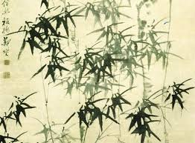

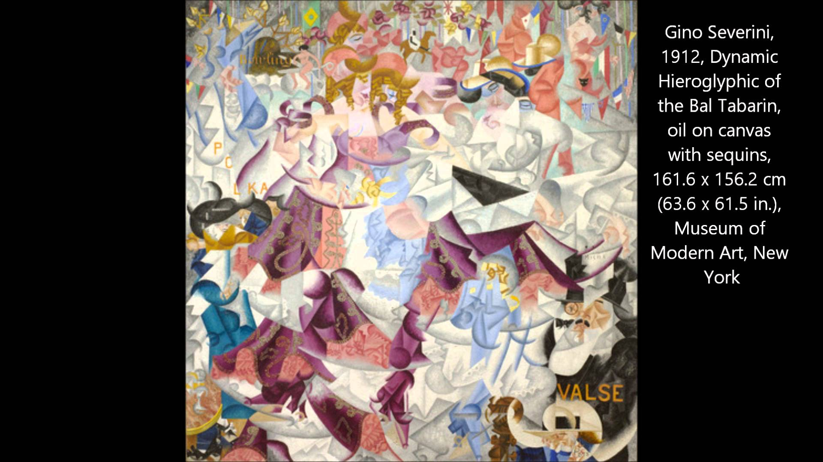

Watch
- Imagist Poetry Intro, Pages 713 717 (Links to an external site.)Links to an external site.
- Jr. T. S. Eliot's Prufrock (Links to an external site.)Links to an external site.
- Jr Intro to T S Eliot, 1 (Links to an external site.)Links to an external site.

Read
- Modern Poetry. Part 1. pp. 649-667 UNIT5649-728.pdf
- Imagists – Modernists: A Brief Guide to Imagism Imagists_Modernists.pdf
- Ezra Pound, In a Station of the Metro (see below)
- S. Eliot. The Love Song of J. Alfred Prufrock (see below)

Research and answer
Use evidence from the text to support your opinion

Ezra Pound

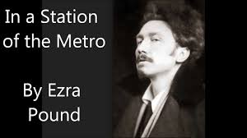
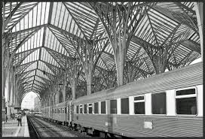

In a Station of the Metro

The apparition of these faces in the crowd;
Petals on a wet, black bough.

Questions on Ezra Pound:
- In the first line of “In a Station of the Metro”, what word does the speaker use to describe how the faces look to him? What might that word suggest about the faces?
- In the second line, to what image does the speaker compare the faces? From this image, what can you infer about the speaker’s feeling?
- Is the tone of the poem optimistic or pessimistic? Why? What deeper sense can you reveal there? Does the author approve or criticize current society/trends/habits?

T. S. Eliot
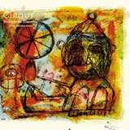

The Love Song of J. Alfred Prufrock

S’io credesse che mia risposta fosse
A persona che mai tornasse al mondo,
Questa fiamma staria senza piu scosse.
Ma percioche giammai di questo fondo
Non torno vivo alcun, s’i’odo il vero,
Senza tema d’infamia ti rispondo.

Let us go then, you and I,
When the evening is spread out against the sky
Like a patient etherized upon a table;
Let us go, through certain half-deserted streets,
The muttering retreats
Of restless nights in one-night cheap hotels
And sawdust restaurants with oyster-shells:
Streets that follow like a tedious argument
Of insidious intent
To lead you to an overwhelming question ...
Oh, do not ask, “What is it?”
Let us go and make our visit.

In the room the women come and go
Talking of Michelangelo.

The yellow fog that rubs its back upon the window-panes,
The yellow smoke that rubs its muzzle on the window-panes,
Licked its tongue into the corners of the evening,
Lingered upon the pools that stand in drains,
Let fall upon its back the soot that falls from chimneys,
Slipped by the terrace, made a sudden leap,
And seeing that it was a soft October night,
Curled once about the house, and fell asleep.

And indeed there will be time
For the yellow smoke that slides along the street,
Rubbing its back upon the window-panes;
There will be time, there will be time
To prepare a face to meet the faces that you meet;
There will be time to murder and create,
And time for all the works and days of hands
That lift and drop a question on your plate;
Time for you and time for me,
And time yet for a hundred indecisions,
And for a hundred visions and revisions,
Before the taking of a toast and tea.

In the room the women come and go
Talking of Michelangelo.

And indeed there will be time
To wonder, “Do I dare?” and, “Do I dare?”
Time to turn back and descend the stair,
With a bald spot in the middle of my hair —
(They will say: “How his hair is growing thin!”)
My morning coat, my collar mounting firmly to the chin,
My necktie rich and modest, but asserted by a simple pin —
(They will say: “But how his arms and legs are thin!”)
Do I dare
Disturb the universe?
In a minute there is time
For decisions and revisions which a minute will reverse.

For I have known them all already, known them all:
Have known the evenings, mornings, afternoons,
I have measured out my life with coffee spoons;
I know the voices dying with a dying fall
Beneath the music from a farther room.
So how should I presume?

And I have known the eyes already, known them all—
The eyes that fix you in a formulated phrase,
And when I am formulated, sprawling on a pin,
When I am pinned and wriggling on the wall,
Then how should I begin
To spit out all the butt-ends of my days and ways?
And how should I presume?

And I have known the arms already, known them all—
Arms that are braceleted and white and bare
(But in the lamplight, downed with light brown hair!)
Is it perfume from a dress
That makes me so digress?
Arms that lie along a table, or wrap about a shawl.
And should I then presume?
And how should I begin?

Shall I say, I have gone at dusk through narrow streets
And watched the smoke that rises from the pipes
Of lonely men in shirt-sleeves, leaning out of windows? ...

I should have been a pair of ragged claws
Scuttling across the floors of silent seas.

And the afternoon, the evening, sleeps so peacefully!
Smoothed by long fingers,
Asleep ... tired ... or it malingers,
Stretched on the floor, here beside you and me.
Should I, after tea and cakes and ices,
Have the strength to force the moment to its crisis?
But though I have wept and fasted, wept and prayed,
Though I have seen my head (grown slightly bald) brought in upon a platter,
I am no prophet — and here’s no great matter;
I have seen the moment of my greatness flicker,
And I have seen the eternal Footman hold my coat, and snicker,
And in short, I was afraid.

And would it have been worth it, after all,
After the cups, the marmalade, the tea,
Among the porcelain, among some talk of you and me,
Would it have been worth while,
To have bitten off the matter with a smile,
To have squeezed the universe into a ball
To roll it towards some overwhelming question,
To say: “I am Lazarus, come from the dead,
Come back to tell you all, I shall tell you all”—
If one, settling a pillow by her head
Should say: “That is not what I meant at all;
That is not it, at all.”

And would it have been worth it, after all,
Would it have been worth while,
After the sunsets and the dooryards and the sprinkled streets,
After the novels, after the teacups, after the skirts that trail along the floor—
And this, and so much more?—
It is impossible to say just what I mean!
But as if a magic lantern threw the nerves in patterns on a screen:
Would it have been worth while
If one, settling a pillow or throwing off a shawl,
And turning toward the window, should say:
“That is not it at all,
That is not what I meant, at all.”

No! I am not Prince Hamlet, nor was meant to be;
Am an attendant lord, one that will do
To swell a progress, start a scene or two,
Advise the prince; no doubt, an easy tool,
Deferential, glad to be of use,
Politic, cautious, and meticulous;
Full of high sentence, but a bit obtuse;
At times, indeed, almost ridiculous—
Almost, at times, the Fool.

I grow old ... I grow old ...
I shall wear the bottoms of my trousers rolled.

Shall I part my hair behind? Do I dare to eat a peach?
I shall wear white flannel trousers, and walk upon the beach.
I have heard the mermaids singing, each to each.

I do not think that they will sing to me.

I have seen them riding seaward on the waves
Combing the white hair of the waves blown back
When the wind blows the water white and black.
We have lingered in the chambers of the sea
By sea-girls wreathed with seaweed red and brown
Till human voices wake us, and we drown.

Questions on T.S. Eliot:

- Who is the speaker of "The Love Song of J. Alfred Prufrock"?
- The speaker compares the sunset to a "patient etherised upon a table." Why do you suppose Prufrock would compare a sunset to some hospital patient who has been anesthetized and is waiting for an operation?
- The speaker refers to the surrounding cityscape as having "one-night cheap hotels" and "sawdust restaurants." What is this part of town like, apparently?
- What is the yellow fog compared to in a simile? How is the fog like such a creature?
- What does Prufrock mean when he says, "There will be time, there will be time / To prepare a face to meet the faces that you meet"? Have you ever had to "prepare a face" before you have met someone? Why would one try to prepare an artificial face?
- Prufrock reassures himself that there will be "Time to turn back and descend the stair." What does he mean by this, i.e., what can he do if he changes his mind? Why do you suppose T. S. Eliot chooses the verb descend rather than ascend? Does this connect with the Dante quotation about a guy trapped in hell in any way?
- Why doesn't Prufrock compare himself to a complete crab? Why is a crab particularly appropriate for Prufrock generally? (Research about the way crabs travel and see how it matches the way Prufrock travels through life....)
- Why is Prufrock agonizing over how to wear his trousers?
- What's odd about the way Prufrock contemplates combing his "hair behind"? Does one normally comb his hair from the rear to cover the forward part of the head? What does this suggest about the aging Prufrock's hair and why he combs his hair forward this way?
- Why is Prufrock stymied by the thought of eating peach? Why would eating a peach in public be problematic for him
- Prufrock imagines himself under the water with the mermaids in "chambers of the sea." What happens at the end though when he hears the conversation of human voices around him that awakens him from his daydream?

